LabVIEW Intro

**Pasco-Ray Programming Guide**

**Team RUSH 27 LabVIEW**

**Matt Pasco**

**Michael Ray**

**LabVIEW Intro**

**Table of Contents**

1. Table of Contents
2. Intro to Variables, Types, and Loops
3. Data Types
   1. Integer
   2. Numeric/Double
   3. String
   4. Boolean
   5. Comparison
4. Data Types Continued
   1. Image of Data Types in LabVIEW
5. Loops
   1. For Loops
   2. While Loops
   3. Case Structures
   4. Timed Structures
   5. Disabled Diagrams
   6. Flat Sequenced
6. Arrays
7. Arrays Continued

1. Loops Continued
   1. Image of Loops in LabVIEW

**Intro to Variables, Types, and Loops**

* **Data Types**
  + Data types are the main Variable types you will be using in LabVIEW. They are color coded and easy to see. They consist of
  + Integer
  + Numeric/Double
  + String
  + Boolean
  + Comparison Tablets
* **Loops**
  + Loops are specific amounts of code that you want to run for the specified amounts of times for certain parameters until something is completed. They Consist of
  + For Loops
  + While Loops
  + Case Structures
  + Timed Structures
  + Disabled Diagrams
  + Flat Sequenced

**Data Types**

* **Integers**
  + **Color Code: Blue**
  + Integers are any **whole** number from -∞ to +∞
  + Example
    - A counter used to count Number of Balls in Robot
* 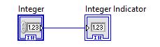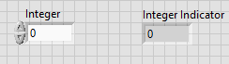
* **Numeric/Double**
  + **Color Code: Orange/Yellow**
  + Any number (can include Decimals) from -∞ to +∞
  + Example
    - Counting Encoder Rotations (has decimals to represent half turns
* 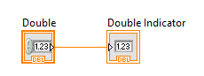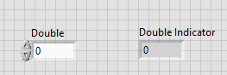
* **String**
  + **Color Code: Pink**
  + Letters/Words
  + Example
    - Read the name of a text file that is place on the cRIO
* 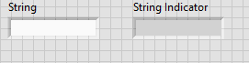
* **Booleans** 
  + **Color Code: Green**
  + True or False/ ON or OFF
    - When a button on a gamepad is hit it becomes True
* 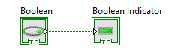
* **Comparison**
  + **Color Code: Green can be changed**
  + Used to compare two variables of the same data type
  + Example
    - Check to see if the encoder rotations are greater than
* 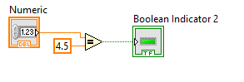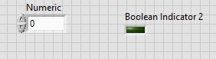

**Arrays**

* **Index**
  + think of it as a coordinate point or as a cell in excel
  + **ALWAYS STARTS AT 0**
  + **1D array**
    - It will only have a single index (x coordinate)
  + 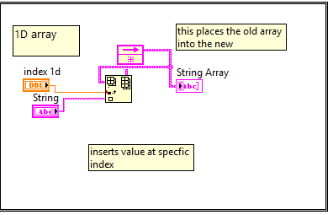
  + 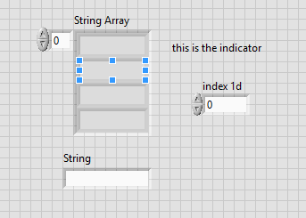
  + **2D array**
    - It will have two (x coordinate and one for y coordinate)
  + 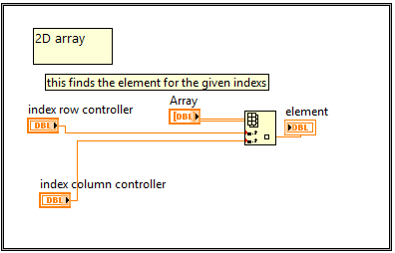
  + 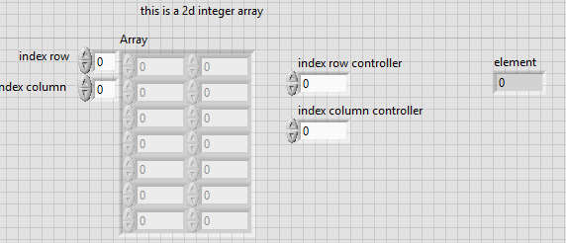
* **Data**
  + **YOU CAN ONLY HAVE ONE DATA TYPE**
  + ex
    - You can have an array of only booleans, you **cannot** have an array of booleans and strings
* **Example**
  + We use arrays for auton storing motor values, direction and case selector values (see page 6) as integers and index 0 be case selector, 1 heading, 2 power, ect...
  + here is an array called string_array
    - string_array(0)= “hello”
    - string_array(1)= “bye”
    - string_array(2) = “robots”
  + So if we send an index value of 1 it will send back “bye”

**Loops**

* **For Loops**
  + A loop that runs for a set amount of times
  + **NOTE:** The number of times includes 0 so if you set it for 4 it will repeat 5 times for 0,1,2,3,4.
  + **Example**
    - I want the counter to update x times
* **While**
  + A loop that repeats until a set condition is met
  + **NOTE:** The loop must be able to repeat
  + **Example**
    - I want to drive the motors while my distance is less than 3ft.
* **Case Structure**
  + A loop that can do different things depending on what is inputted into the case
  + Any variable can be put into it (see page 3 “Data Types”)
  + **Example**
    - If Boolean is true I want my counter to add 1 but if it is false subtract 1.
* **Timed Structures**
  + A loop that iterates every x amount of time
  + **Example**
    - I want to add 1 to the time every 1000ms
* **Disable Diagram** 
  + Used for disabling code
  + **Example**
    - Disabling code that is not complete to test other parts
* **Flat Sequence**
  + Chooses what will run from left to right
  + **Example**
    - I want to turn *then* I will drive *then* I will shoot

